**Trajectories of CAC in the CACTI study – ALL AGES COMBINED**

Using data from all 4 CACTI visits, the trajectories of CAC (volavesqrt) in CACTI participants (T1D and control groups combined) were modeled using group-based trajectory methods. First, the FCAP program (Klijn et al.) was used to run models with 1 to 10 groups. The resulting output (particularly the Bayesian Information Criterion and the percent of participants in the smallest group) was used to select several models that potentially fit the data best.

The model with 9 groups had the highest BIC (Figure 1), although the rate of increase in BIC leveled off at 4 groups. The size of the smallest group reached the minimum using 6 groups, but remained above 1% for all models considered. Based on these statistical criteria, combined with the need to keep the number of groups relatively low to aid interpretation, the final models selected included 3-5 groups.

Figure 1. Model selection criteria for models with 1-10 groups.

Figure 2. Percentages of individuals belonging to the smallest group.

Following the recommendation of Klijn et al. to first select the number of classes and then the order of polynomials, models using 3-5 classes and polynomial orders from 1-3 and are described below.

Using BIC, the model with 5 classes and quadratic polynomials performs the best.

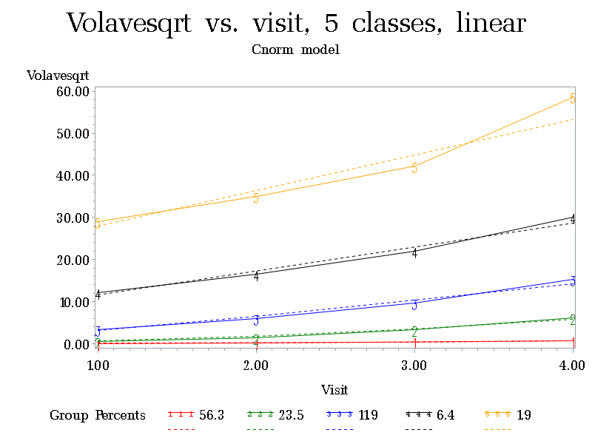

BIC = -6925.08

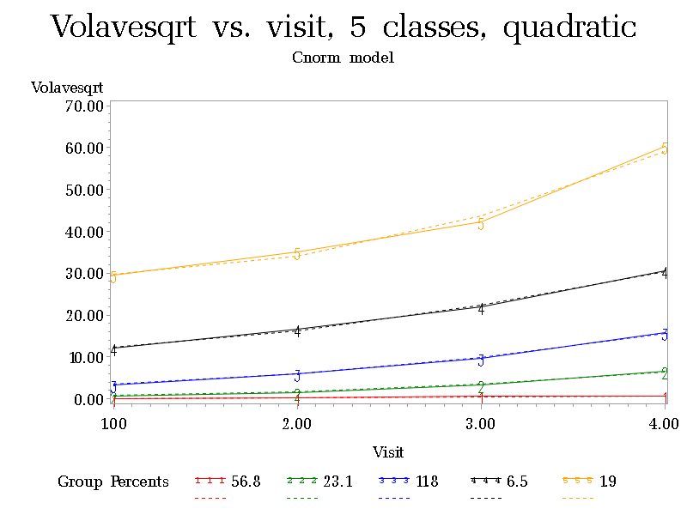

Quadratic term was significant in all 5 classes, BIC = -6914.50.

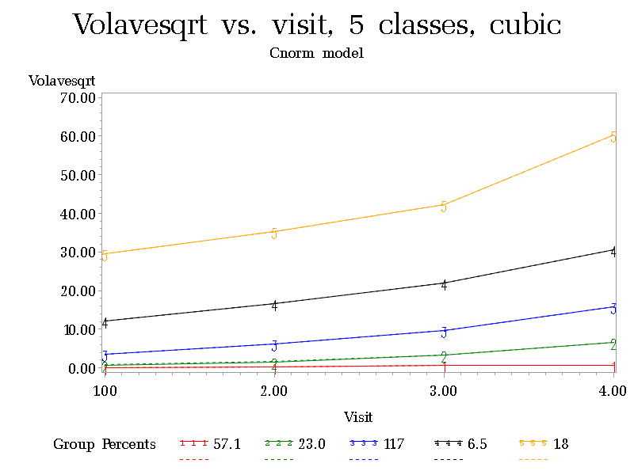

Cubic term was significant in 2 of 5 classes, BIC = -6926.18

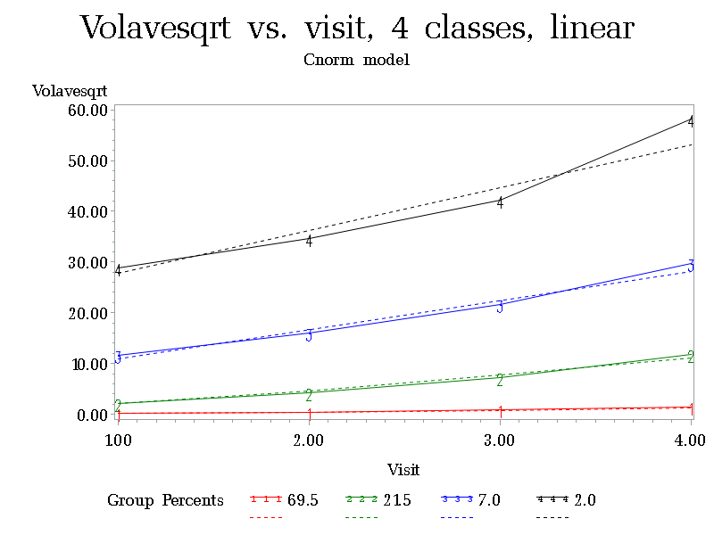

BIC = -6974.60

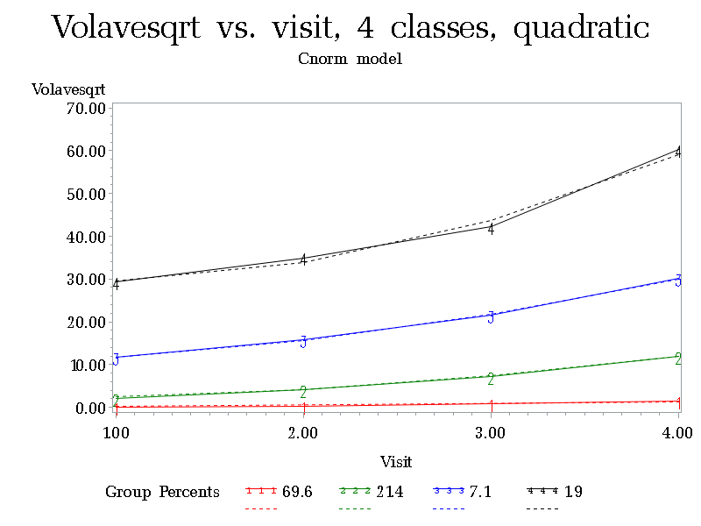

The quadratic term was significant in 3 of 4 classes, BIC = -6967.30

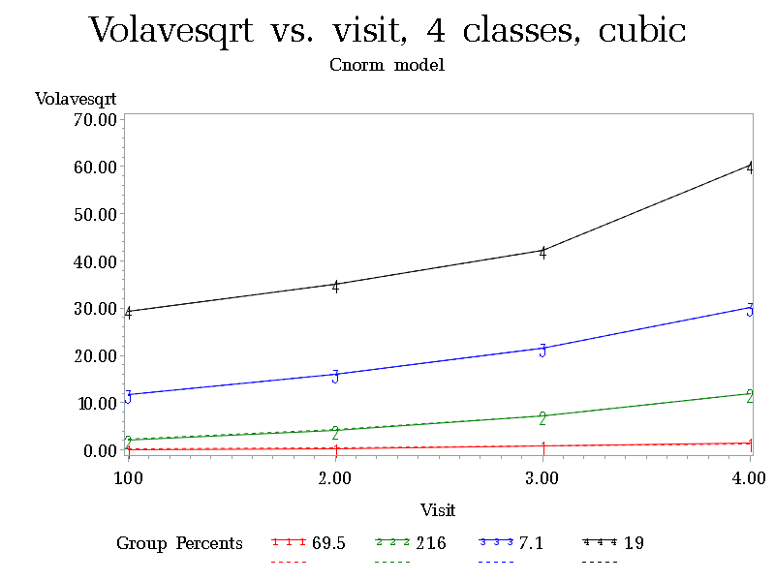

The cubic term was significant in 1 of 4 classes, BIC = -6977.47

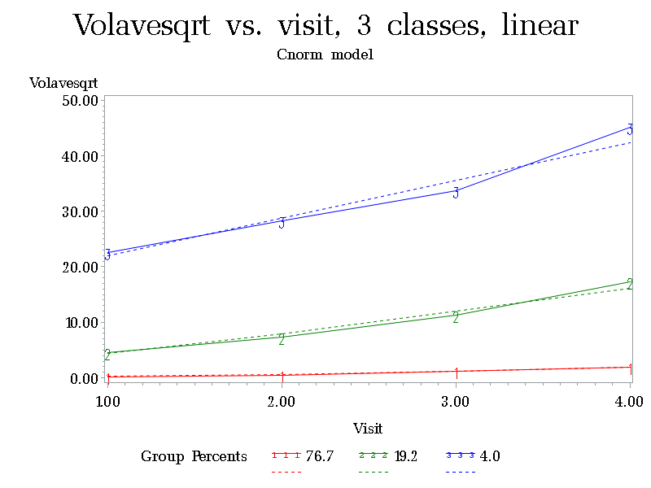

BIC = -7241.60

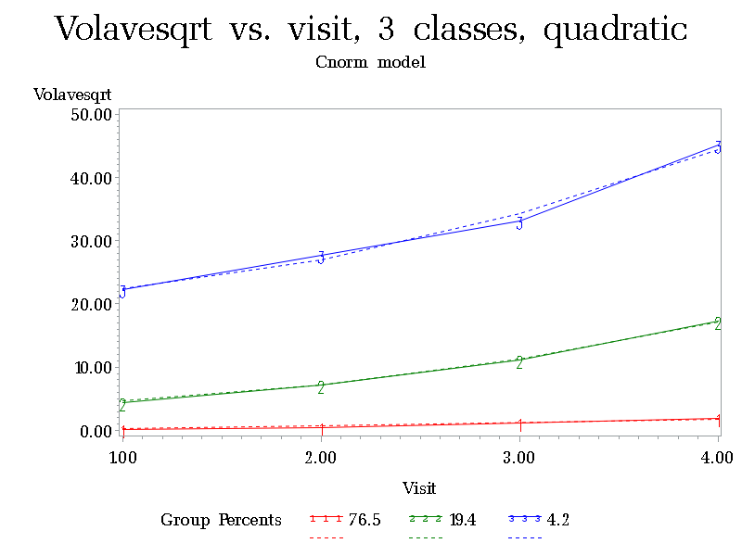

The quadratic term was significant in 2 of 3 classes, BIC = -7241.39

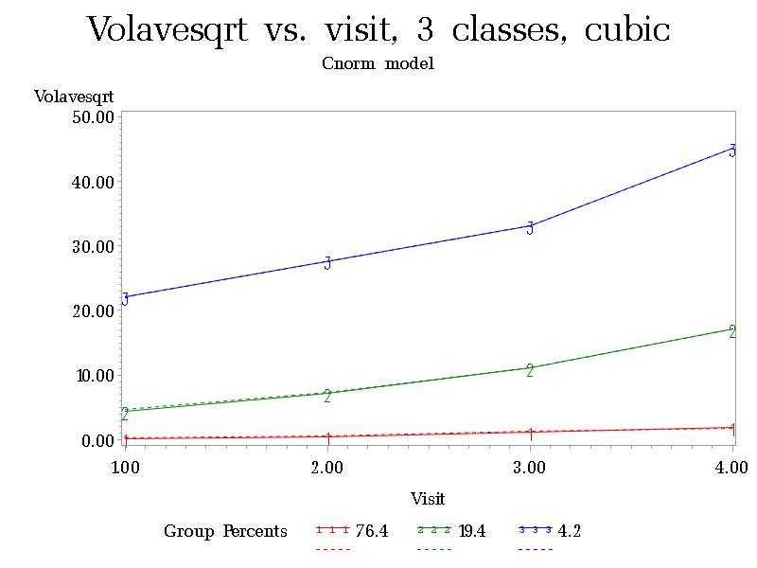

The cubic term was significant in 0 of 3 classes, BIC = -7249.63

References

Klijn SL, Weijenberg MP, Lemmens P, van den Brandt PA, Lima Passos V. Introducing the fit-criteria assessment plot – A visualization tool to assist class enumeration in group-based trajectory modelling. Statistical Methods in Medical Research 2017; 26(5):2424-2436.